# ASSIGNMENT

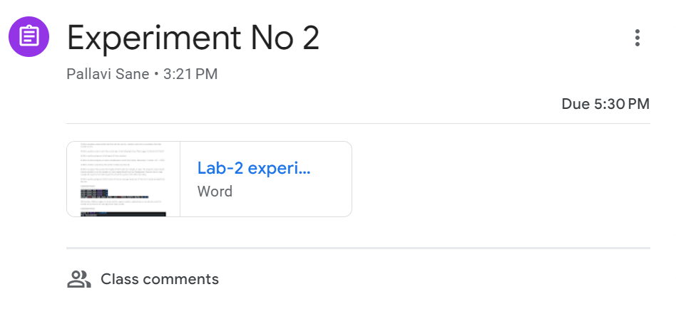

PREPARED BY:

SAMAR MITTAL

112315159

Task 1:

n=int(input("Enter number : "))

if (n%2==0):

    print("Entered number is even")

else:

    print("Entered number is odd")

OUTPUT:

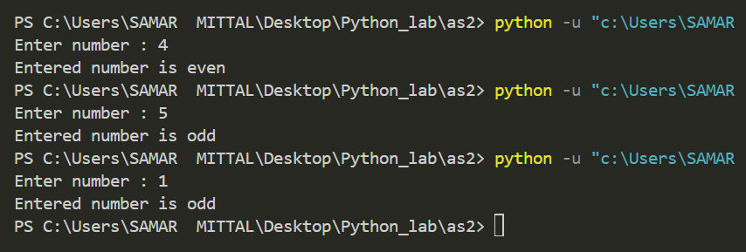

TASK 2:

for i in range(2,11):

    print("1/",i,"=",1/i)

OUTPUT:

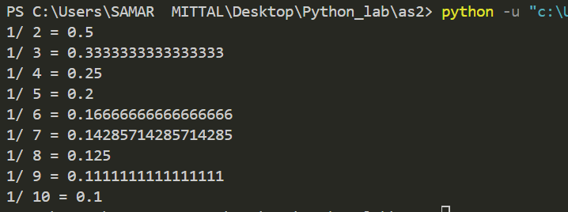

TASK 3:

n=int(input("Enter countdown number : "))

while(n>=0):

    print(n)

    n=n-1

OUTPUT:

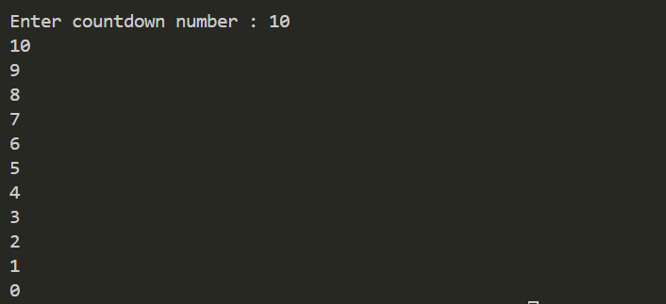

TASK 4:

from datetime import datetime

t=datetime.now()

print(t.strftime('%A'),t.strftime('%B'),t)

OUTPUT:

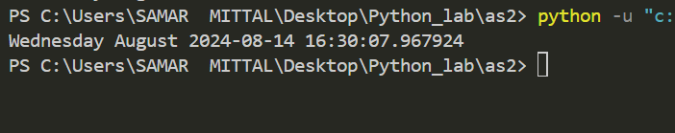

TASK 5:

a=-1000

for i in range(0,3):

    b=int(input("Enter number : "))

    if a<b:

        a=b

print("Max of entered number : ",a)

OUTPUT:

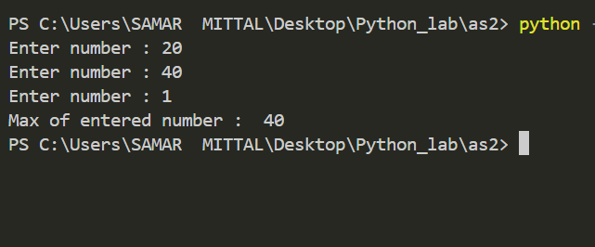

TASK 6:

n=float(input("Enter temperature : "))

str=input("Enter degree C->Celcius and F-> fahrenhiet : ")

if (str=='c' or str=='C'):

    print("Temperature in Celcius : ",n)

    print("Temperature in Fahrenheit : ",((9/5)*n) + 32)

elif(str=='F' or str=='f'):

    print("Temperature in Fahrenheit : ",n)

    print("Temperature in Celcius : ",((n-32)*5)/9)

OUTPUT:

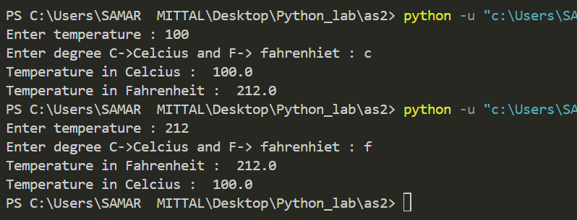

TASK 7:

for i in range(2,21):

    curr=i

    flag=1

    for j in range(2,i-1):

        if curr%j==0:

            flag=0

            break

    if (flag==1):

        print(curr,*end*=" ")

OUTPUT:

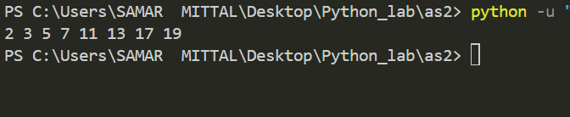

TASK 8:

p=float(input("Enter perpendicular : "))

b=float(input("Enter base : "))

h=float(input("Enter hypotenus : "))

if (h*h==(p*p+b*b)):

    print("Entered triangle is Right-angled ")

else:

    print("Not a right-angled Triangle")

OUTPUT:

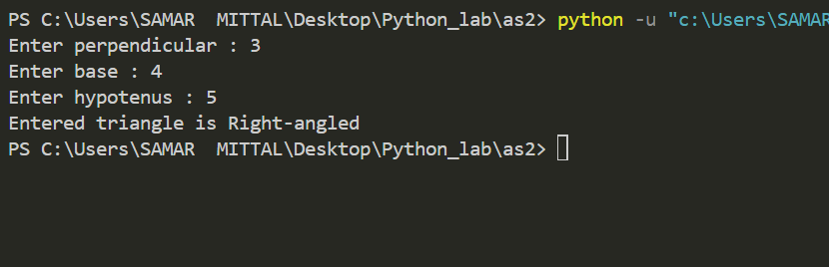

TASK 9:

a=int(input("Enter test 1 : "))

b=int(input("Enter test 2 : "))

c=int(input("Enter test 3 : "))

small=min(a,b,c)

print("Average of best two test marks out of three test’s marks is ",(a+b+c-small)/2)

OUTPUT:

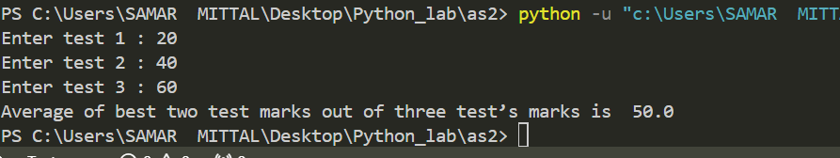

TASK 10:

num=int(input("Enter a number:"))

reversenum=0

n=num

Dict={1:0,2:0,3:0,4:0,5:0,6:0,7:0,8:0,9:0,0:0}

while n>0:

    t=n%10

    Dict[t]+=1

    reversenum=(reversenum*10)+t

    n=n//10

if num==reversenum :

    print(num,"is palindrome")

else :

    print(num,"is not a palindrome")

for key in Dict.keys():

    if (Dict[key]!=0):

        print(key,"appears",Dict[key],"times in number")

OUTPUT:

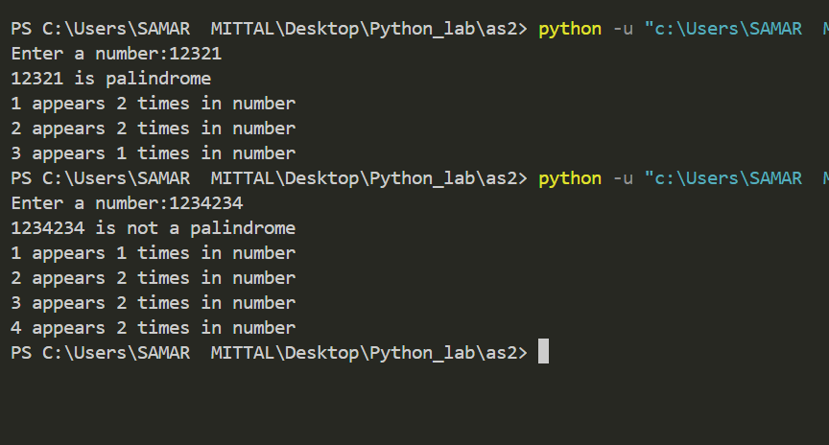

TASK 11:

s=input("Enter string : ")

word,digit,up,low=1,0,0,0

for ch in s:

    if ch.isdigit():

        digit+=1

    if ch==" ":

        word+=1

    if ch.islower():

        low+=1

    if ch.isupper():

        up+=1

print("This sentence has ",word," words")

print("This sentence has ",digit," digits")

print("This sentence has ",up," uppercase")

print("This sentence has ",low," lowercase")

OUTPUT:

